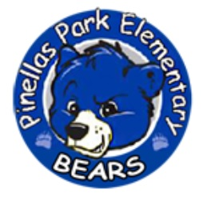

Pinellas Park Elementary School Advisory Committee

The School Advisory Council (SAC) is a team that represents various segments of our community – parents, teachers, students, administrators, support staff, business/industry people and other interested community members. The purpose of the SAC is to assist in developing and evaluating the results of the School Improvement Plan and to assist the principal with the annual school budget.

The activities of the council enrich the learning environment of Pinellas Park Elementary by assisting in the preparation and evaluation of the annual School Improvement Plan (SIP). The SIP is our locally created blueprint on how to best improve our school, which establishes educational priorities and informs the school’s annual budget. The SAC utilizes collaboration and data-driven decision making​ to identify problem areas and develop improvement strategies that are sensitive to the needs of ​each of the communities served by the school.

Innovation for continuous improvement is a group effort that takes advantage of the representation of the diverse backgrounds and perspectives that make up our school and community. ​Because of this, we host a monthly public meeting in the Media Center.​ ​Please join us for a meeting​ to see what we are working on, and to share your unique perspective as one of our valued community members!

If you have any questions about SAC, please contact.

School Improvement Plans: https://www.pcsb.org/Page/16901